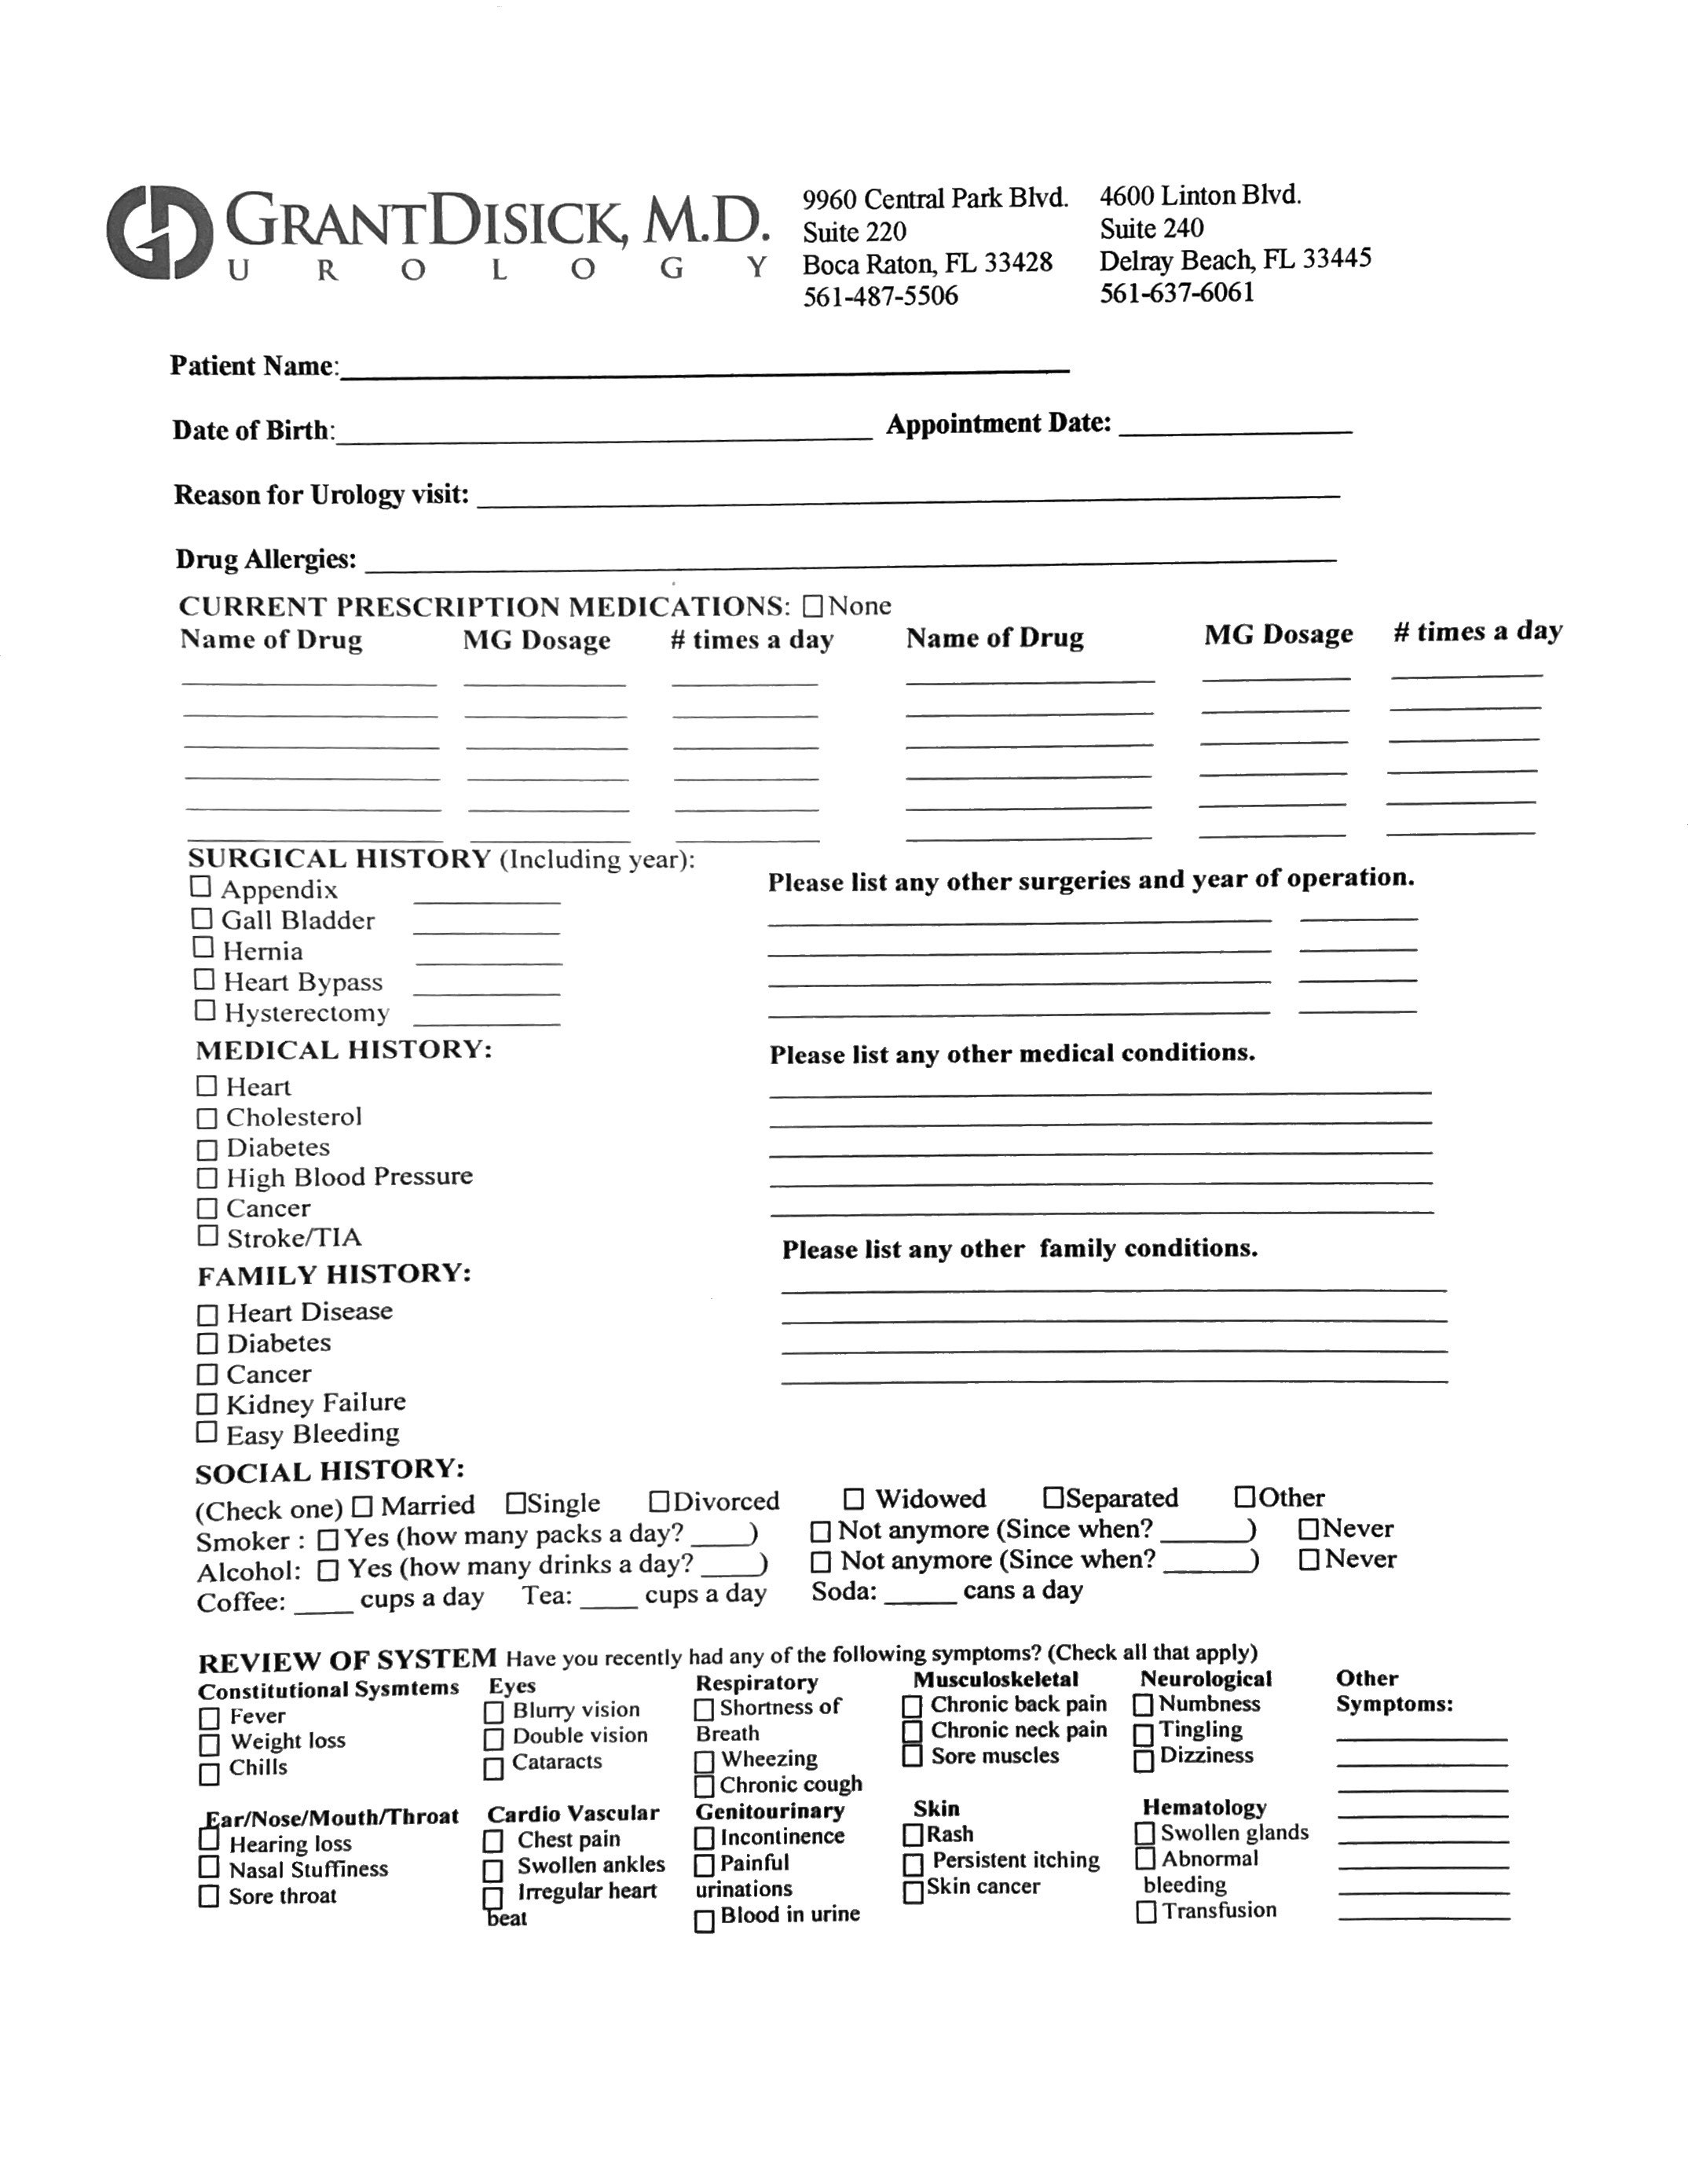
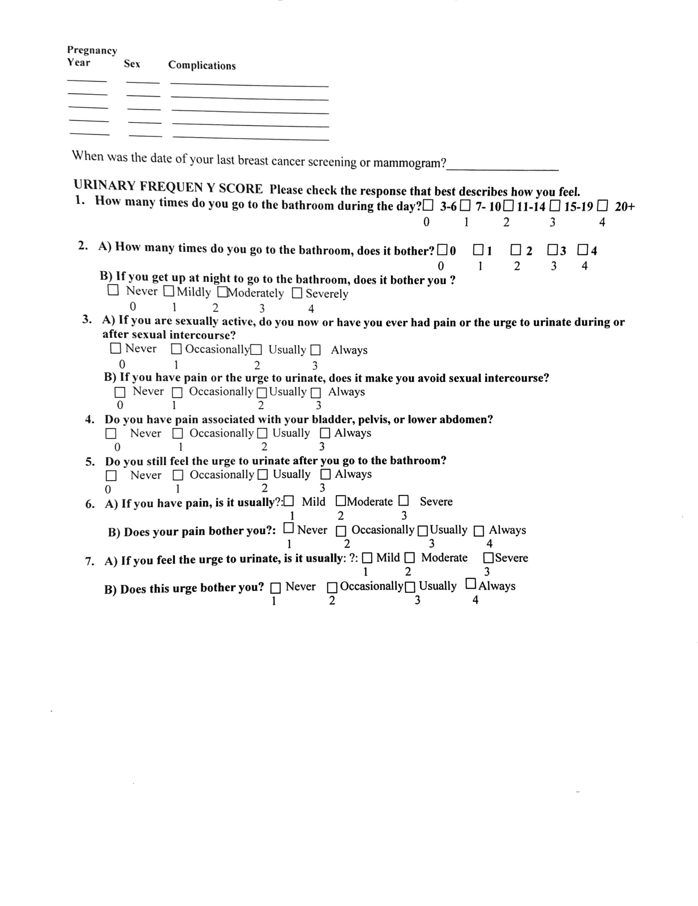

PATIENT INFORMATION: ___________________ (I HAVE REVIEWED ALL THE INFORMATION BELOW IS ACCURATE)
^{PATIENT} ^{INITIALS}
Office: |  |  |  |  |  |  |  |  |  |  |  |  |  |  | Date:
Last Name: |  |  |  |  |  |  |  |  |  |  |  |  |  |  | First Name: |  |  |  |  |  |  |  |  |  |  |  | M.I.:
SSN: |  |  |  |  |  |  |  |  |  |  |  |  |  |  | DOB: |  |  |  |  |  |  |  |  |  | Sex:
Address: |  |  |  |  |  |  |  |  |  |  |  |  |  |  | Apt/Suite #:
City: |  |  |  |  |  |  |  |  |  |  |  |  |  |  | State: |  |  |  |  |  |  |  |  | Zip:
Home Phone: |  |  |  |  |  |  |  |  |  |  |  |  |  |  | Mobile Phone:
E-Mail Address:
Primary Care Physician: |  |  |  |  |  |  |  |  |  |  |  |  |  | Referring Provider:
Employer: |  |  |  |  |  |  |  |  |  |  |  |  |  |  | Work Phone:
Marital Status: |  |  |  |  |  |  |  |  |  |  |  |  |  |  | Is your spouse working or retired?
Spouse Name: |  |  |  |  |  |  |  |  |  |  |  |  |  |  | Spouse DOB:
Spouse SSN: |  |  |  |  |  |  |  |  |  |  |  |  |  |  | Spouse Contact Number:

ALTERNATE ADDRESS: ___________________ (I HAVE REVIEWED ALL THE INFORMATION BELOW IS ACCURATE)
^{PATIENT} ^{INITIALS}
- I do not have an alternate address
Alternate Address: |  |  |  | Apt/Suite#:
City: |  |  |  | State: |  |  | Zip:

INSURANCE INFORMATION: ___________________ (I HAVE REVIEWED ALL THE INFORMATION BELOW IS ACCURATE)
^{PATIENT} ^{INITIALS}
Primary Insurance: |  |  |  |  | Plan ID:
Group #: |  |  |  |  | Phone Number:
Secondary Insurance: |  |  |  |  | Plan ID:
Group #: |  |  |  |  | Phone Number:

EMERGENCY CONTACT INFORMATION: __________________ (I HAVE REVIEWED ALL THE INFORMATION BELOW IS ACCURATE) ^{PATIENT} ^{INITIALS}
Name: |  |  |  |  |  | Phone:
Relationship to Contact: |  |  |  |  |  | Guardian:
Address: |  |  |  |  |  | Apt/Suite #:
City: |  |  |  |  |  | State: |  |  |  |  | Zip:
Are you currently admitted to a hospital or enrolled in a Hospice or Skilled Nursing Facility?

Yes_____ No_____ If yes, please fill out the following:

Facility Name: |  |  |  |  | Phone:
Address:
City: |  |  |  | State: |  |  |  | Zip:

Are you receiving benefits from the Veterans Administration?
Yes_____ No_____ If yes, please fill out the following:
VA Name: |  | Phone:

City: |  | State: |  | Zip:

WHICH OF THE FOLLOWING BEST DESCRIBES YOUR RACE?
Asian | Caucasian | Black / African American | Hispanic
Subcontinent Asian American |  | Asian Pacific American | Native American
American Indian/Alaskan Native |  | Hawaiian | Pacific Islander
More than one race |  | Other | Decline
PLEASE SELECT ONE ETHNIC GROUP THAT BEST DESCRIBES YOUR ANCESTRY:
Hispanic or Latino | Non-Hispanic or Latino
Decline | Don’t know
WHAT LANGUAGE DO YOU FEEL MOST COMFORTABLE USING WHEN DISCUSSING YOUR HEALTHCARE?
English | Spanish | German | French
Italian | Russian | Portuguese | Chinese
Creole | Other | Decline
WE ARE DEDICATED TO PROVIDING THE BEST CARE POSSIBLE TO OUR PATIENTS. WE CAN BETTER ACCOMPLISH THIS GOAL BY OBTAINING YOUR OPINION ON HOW WE ARE DOING. MAY WE CONTACT YOU BY MAIL, E-MAIL, TEXT, OR TELEPHONE FOR OUR SURVEY? Survey communications are sent via standard unsecure email and can place your information at risk of being read or accessed by someone else. By checking yes, you agree to receiving the survey via standard unsecure (unencrypted) email.
Yes | No
HOW DID YOU HEAR ABOUT US?
Physician Referral |  | Family or Friend |  |  | Insurance Referral
Internet (website, search engine, Facebook, etc) |  |  |  | Media (newspaper, magazine, billboard, radio, TV)
Hospital | VA |  | Integrative Oncology Essentials |  |  | Communications Forum (Seminar, etc.)
No Response
WHEN CONDUCTING YOUR OWN RESEARCH, HOW OFTEN DO YOU USE THE INTERNET FOR GATHERING INFORMATION?
Always | Usually | Sometimes | Never

Telephone Consumer Protection Act [TCPA] Consent Form

Active communication with our patients is a key element in providing high quality health care services. To that end, GenesisCare desires to communicate timely information regarding health care services and functions to you in the most effective means possible, including via automated telephone and text messaging. Federal law requires that we obtain your consent prior to communicating with you via these means. Please read and sign below so that we can communicate with you for these important purposes. We apologize for the formality of this consent, but it is required under law.

I authorize the use of my personal information, the name of my care provider, the time and place of my scheduled appointment(s), and other limited information, for the purpose of notifying me of a pending appointment, a missed appointment, overdue wellness exam, balances due, lab results, or any other healthcare related function. I consent to receiving multiple messages per day from my healthcare provider, when necessary, and I consent to allowing messages being left on my voice mail, answering system, or with another individual, if I am unavailable at the number provided by me.

I also authorize any of GENESISCARE USA OF FLORIDA - FBU independent contractors agents and/or affiliates (“collectively, “Practice”) to contact me through the use of any dialing equipment or an artificial voice or prerecorded voice or other messaging system, at any telephone number associated with my account including wireless telephone numbers, provided by me or found by means of skip tracing methods even if I am charged for the call, as well as through any email address or other personal contact information supplied by me. I expressly consent to receive any such automated calls. I understand that, depending on my plan, charges may apply to certain calls or text messages. I also understand that communication platforms may transmit information via unsecure methods which includes a risk that the information could be viewed by an unintended third party. I understand these risks and consent to having these communications sent unsecure.

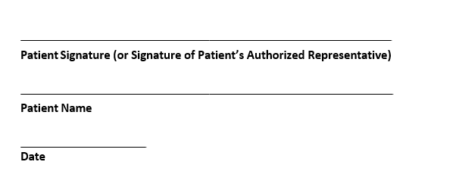

Patient Permission To Communicate Information With
Designated Individuals

Our physicians and staff know that communicating with you about your healthcare is important. By completing this form, you give us permission to provide messages, and/or discuss information about your healthcare with the individuals designated below. I understand that I may cancel or update this information at any time by notifying a representative of the physician office.

- I give permission to allow physicians and staff to discuss relevant medical, billing, and insurance information with the individuals listed below (examples, spouse, relatives, friend, etc.). I understand that my healthcare provider will use professional judgment to determine what information about my healthcare may be discussed with the designated individuals below*:

Involved Individual Relationship to Patient Phone Number

Patient/Authorized Representative Signature**____________________________________________Date_____________Time________

Printed Name of Authorized Representative: _____________________________________________
Relationship to Patient: _________________________________

**If signed by a patient-authorized representative, supporting legal documentation must accompany this authorization form.

*GenesisCare expressly reserves the right to disclose information to others who may not be on the list if and to the extent allowed by HIPAA, including but not limited to disclosures for treatment, payment or healthcare operations.

Assignment Of Benefits/Right To Payment Authorization, Patient Responsibility, And Release Of Information Form

GenesisCare
DBA GENESISCARE USA OF FLORIDA - FBU
PO Box 862152
Orlando, FL 32886-2152

I, the undersigned, assign to the provider/entity referenced above (“Provider”), my rights and benefits in any medical insurance plan, health benefit plan, or other source of payment for healthcare services (each a “Plan”) in connection with medical services provided by Provider, its employees and agents. I understand that this document is a direct assignment of my rights and benefits under my Plan.

I authorize my insurance company to pay Provider directly for the professional or medical expense benefits payable to me. If my current policy prohibits direct payment to Provider, I instruct my insurance company to make out the check to me and mail it directly to the address of lockbox referenced above for the professional or medical expense benefits payable to me under my Plan as payment towards the total charges for the services rendered. In addition, I agree and understand that any funds I receive by my insurance company due for services rendered by Provider are owed to Provider and I agree to remit those funds directly to Provider.

Patient Responsibility
I acknowledge and agree that I am responsible for all charges for services provided to me which are not covered by my Plan or for which I am responsible for payment under my Plan. To the extent no coverage exists under my Plan, I acknowledge that I am responsible for all charges for services provided and agree to pay all charges not covered by my Plan.

Release of Information
I authorize Provider and/or its agents to release any medical or other information about me in its possession to my Plan, the Social Security Administration, any state administrative agency, or their intermediaries or fiscal agents required or requested in connection with any claim for services rendered to me by Provider.

A photocopy of this Assignment/Authorization shall be considered as effective and valid as the original.

________________________________ ____________________
Signature of Patient/Person Legally Responsible ^{Date}
________________________________ ____________________
Print Name of Patient/Person Legally Responsible ^{Date}
_________________________________________
Relationship to Patient (if signed by Person Legally Responsible)

THIS NOTICE DESCRIBES HOW MEDICAL INFORMATION ABOUT YOU MAY BE USED AND DISCLOSED AND HOW YOU CAN GET ACCESS TO THIS INFORMATION. PLEASE REVIEW IT CAREFULLY.
Each time you visit our physicians or receive treatment from us, a record of your visit is made. This record may contain your symptoms, examination and test results, diagnoses, treatment, a plan for future care or treatment, and billing-related information. This notice applies to all of the records of your care generated by your physician.
Our Responsibilities
We are required by law to maintain the privacy of your protected health information, to provide you with notice of our legal duties and privacy practices with respect to that protected health information, and to notify any affected individuals following a breach of any unsecured protected health information. We will abide by the terms of the notice currently in effect.
Uses and Disclosures - How we may use and disclose protected health information about you
For Treatment: We may use protected health information about you to provide you with treatment or services. We may disclose protected health information about you to doctors, nurses, or other personnel who are involved in taking care of you. For example, we may need to communicate with your primary care doctor to plan your treatment and follow-up care.
For Payment: We may use and disclose protected health information about your treatment and services to bill and collect payment from you, your insurance company, or a third-party payer. For example, we may need to give your insurance company information about your diagnosis so that it will pay us or reimburse you for the treatment.
For Healthcare Operations: We may use or disclose, as needed, your protected health information in order to run our practice. For example, members of the medical staff and/or quality improvement team may use information in your health record to assess the care and outcomes in your case and others like it. The results will then be used to continually improve the quality of care for all patients we serve. 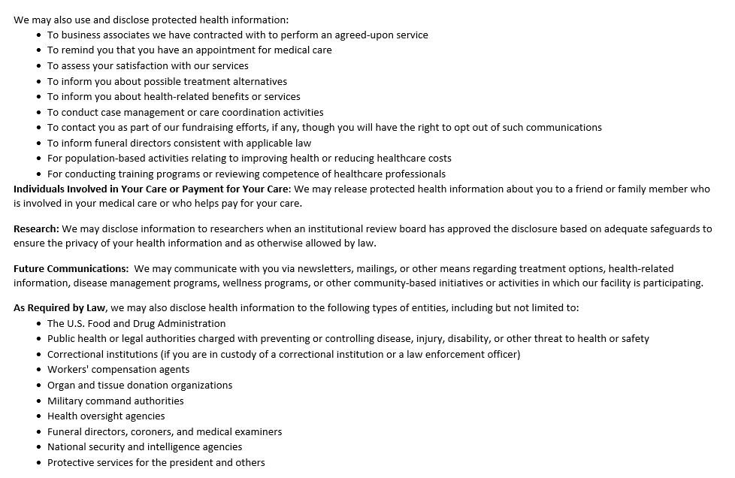
THIS NOTICE DESCRIBES HOW MEDICAL INFORMATION ABOUT YOU MAY BE USED AND DISCLOSED AND HOW YOU CAN GET ACCESS TO THIS INFORMATION. PLEASE REVIEW IT CAREFULLY.
Each time you visit our physicians or receive treatment from us, a record of your visit is made. This record may contain your symptoms, examination and test results, diagnoses, treatment, a plan for future care or treatment, and billing-related information. This notice applies to all of the records of your care generated by your physician.
Our Responsibilities
We are required by law to maintain the privacy of your protected health information, to provide you with notice of our legal duties and privacy practices with respect to that protected health information, and to notify any affected individuals following a breach of any unsecured protected health information. We will abide by the terms of the notice currently in effect.
Uses and Disclosures - How we may use and disclose protected health information about you
For Treatment: We may use protected health information about you to provide you with treatment or services. We may disclose protected health information about you to doctors, nurses, or other personnel who are involved in taking care of you. For example, we may need to communicate with your primary care doctor to plan your treatment and follow-up care.
For Payment: We may use and disclose protected health information about your treatment and services to bill and collect payment from you, your insurance company, or a third-party payer. For example, we may need to give your insurance company information about your diagnosis so that it will pay us or reimburse you for the treatment.
For Healthcare Operations: We may use or disclose, as needed, your protected health information in order to run our practice. For example, members of the medical staff and/or quality improvement team may use information in your health record to assess the care and outcomes in your case and others like it. The results will then be used to continually improve the quality of care for all patients we serve.
We may also use and disclose protected health information:
- To business associates we have contracted with to perform an agreed-upon service
- To remind you that you have an appointment for medical care
- To assess your satisfaction with our services
- To inform you about possible treatment alternatives
- To inform you about health-related benefits or services
- To conduct case management or care coordination activities
- To contact you as part of our fundraising efforts, if any, though you will have the right to opt out of such communications
- To inform funeral directors consistent with applicable law
- For population-based activities relating to improving health or reducing healthcare costs
- For conducting training programs or reviewing competence of healthcare professionals
Individuals Involved in Your Care or Payment for Your Care: We may release protected health information about you to a friend or family member who is involved in your medical care or who helps pay for your care.
Research: We may disclose information to researchers when an institutional review board has approved the disclosure based on adequate safeguards to ensure the privacy of your health information and as otherwise allowed by law.
Future Communications: We may communicate with you via newsletters, mailings, or other means regarding treatment options, health-related information, disease management programs, wellness programs, or other community-based initiatives or activities in which our facility is participating.
As Required by Law, we may also disclose health information to the following types of entities, including but not limited to:
- The U.S. Food and Drug Administration
- Public health or legal authorities charged with preventing or controlling disease, injury, disability, or other threat to health or safety
- Correctional institutions (if you are in custody of a correctional institution or a law enforcement officer)
- Workers' compensation agents
- Organ and tissue donation organizations
- Military command authorities
- Health oversight agencies
- Funeral directors, coroners, and medical examiners
- National security and intelligence agencies
- Protective services for the president and others
Law Enforcement/Legal Proceedings: We may disclose health information for law enforcement purposes as required by law or in response to a valid subpoena or court order.
Other Uses of Your Protected Health Information That Require Your Authorization
Uses and disclosures of your protected health information that involve the release of psychotherapy notes (if any), marketing, sale of your protected health information, or other uses and disclosures not described in this notice or required by law will be made only with your separate written permission. If you give us permission to use or disclose protected health information about you, you may revoke that permission, in writing, at any lime. If you revoke your permission, we will no longer use or disclose protected health information about you for the reasons covered by your written authorization. You understand that we are unable to take back any disclosures we have already made with your permission and that we are required to retain our records of the care that we provided to you.
Your Health Information Rights
Although your health record is the physical property of the healthcare practitioner or facility that compiled it, you have the right to:
- Inspect and copy protected health information. You may request access to your records by contacting us. You may also ask that we send your health information directly to another person based on your signed written instructions. We may deny your request to inspect and copy in certain, very limited circumstances. If you are denied access to protected health information, you may request that the denial be reviewed in some situations. Another licensed healthcare professional chosen by us will review your request and the denial. The person conducting the review will not be the person who denied your request. We will comply with the outcome of the review. We reserve the right to charge you a reasonable fee to cover the cost of providing you with a copy of your records.
- Request an amendment. If you feel that protected health information we have about you is incorrect or incomplete, you may ask us to amend the information by making a request in writing that explains the reason for the requested amendment. You have the right to request an amendment for as long as the information is kept for or by us. We may deny your request for an amendment; if this occurs, you will be notified of the reason for the denial.
- Request an accounting of disclosures. This is a list of certain disclosures we make of your protected health information for purposes other than treatment, payment, healthcare operations, or certain other permitted purposes.
- Request restrictions or limitations on the protected health information we use or disclose about you for treatment, payment, or healthcare operations. You also have the right to request a limit on the protected health information we disclose about you to someone who is involved in your care or the payment for your care, such as a family member or friend. For example, you could ask that we not use or disclose information about a surgery you had. We are not required to agree to your request, except as described below. If we do agree, we will comply with your request unless the information is needed to provide you emergency treatment. If you ask us not to disclose your health information to your health plan, we will agree as long as (i) the disclosure would be for the purpose of payment or health care operations and is not otherwise required by law and (ii) the information only relates to items or services that someone other than your health plan has paid for in full.
- Request confidential communications. You have the right to request that we communicate with you about medical matters in a certain way or at a certain location. For example, you may ask that we contact you at work or by U.S. mail. We will grant requests for confidential communications at alternative locations and/or via alternate means only if the request is submitted in writing and the written request includes a mailing address where you will receive bills for services rendered by the facility and related correspondence regarding payment for services. Please realize that we reserve the right to contact you by other means and at other locations if you fail to respond to any communication from us that requires a response.
- A paper copy of this notice. You may ask us to give you a copy of this notice at any time. Even if you have agreed to receive this notice electronically, you are still entitled to a paper copy of this notice. You may obtain a copy of this notice at our Web site at www.genesiscare.com/us/.
Changes to This Notice
We reserve the right to change this notice; the revised notice will be effective for information we already have about you as well as any information we receive in the future. The current notice will be posted in the facility and will include the new effective date. Copies of any revised notices will be available on our website and will be provided to you upon your next visit to our facility after the effective date.
Complaints
If you believe your privacy rights have been violated, you may file a complaint with us by contacting our Privacy Officer toll-free at 1-866-679- 8944, or by contacting the Secretary of the U.S. Department of Health and Human Services.
You will not be penalized for filing a complaint.
For further information, contact:
Chief Privacy Officer
2270 Colonial Boulevard
Fort Myers, FL 33907
1-866-679-8944

Language Assistance Services for Individuals with Limited English Proficiency

Attention: If you speak English, language assistance services, free of charge, are available to you.
Please call: (833) 796-9684
Notice of Non-Discrimination

Discrimination is Against the Law

GenesisCare USA complies with applicable Federal civil rights laws and does not discriminate on the basis of race, color, national origin, age, disability, or sex. GenesisCare USA does not exclude people or treat them differently because of race, color, national origin, age, disability, or sex.

GenesisCare USA:

- Provides free aids and services to people with disabilities to communicate effectively with us, such as:
  - Qualified sign language interpreters
  - Written information in other formats (large print, audio, accessible electronic formats, other formats)
- Provides free language services to people whose primary language is not English, such as:
  - Qualified interpreters
  - Information written in other languages

If you need these services, please contact your physician office.

If you believe that GenesisCare USA has failed to provide these services or discriminated in another way based on race, color, national origin, age, disability, or sex, you can file a grievance with: Civil Rights Coordinator, 2270 Colonial Blvd, Fort Myers, FL 33907, 866-679-8944, CivilRightsCoordinator@usa.genesiscare.com. You can file a grievance in person or by mail, phone, or email. If you need help filing a grievance, the Civil Rights Coordinator is available to help you.

You can also file a civil rights complaint with the U.S. Department of Health and Human Services, Office for Civil Rights, electronically through the Office for Civil Rights Complaint Portal, available at https://ocrportal.hhs.gov/ocr/smartscreen/main.jsf, or by mail or phone at:

U.S. Department of Health and Human
Services 200 Independence Avenue, SW
Room 509F, HHH Building
Washington, D.C. 20201
1-800-368-1019, 800-537-7697 (TDD)
Complaint forms are available at: https://www.hhs.gov/ocr/complaints/index.html

Acknowledgment of Receipt of Notice of Privacy Practices

I hereby acknowledge:
A copy of the Notice of Privacy Practices was given to me.
If I came in for healthcare services in an emergency treatment situation, I was given the Notice as soon as reasonably practicable after the emergency treatment situation.

_________________________________________ ____________________________
Signature of Patient or Representative Date

_________________________________________
Printed Name of Patient or Representative

FOR OFFICE USE ONLY
If an acknowledgment is not obtained, please complete the information below:

Patient’s name: __________________________________________________________

Date of attempt to obtain acknowledgment: __________________________________

Reason acknowledgement was not obtained:
Patient/family member received notice but refused to sign acknowledgment
Emergency treatment situation
Patient was incapacitated and no family member was present
Unable to communicate due to language barriers
Other (please describe below)

_______________________________________ ____________________________
Signature of Employee Date

